**Musical Mapping of Indore**

Indore is known for its unique, eclectic mix of music; classical and folk, niche and popular, classic rock and death metal. Music is created and performed at various locales of the city – both at formal (music schools, concert halls) as well as informal (cafés) spaces. It is also the home to four prominent gharanas of Hindustani classical music—Maihar Gharana, Gwalior Gharana, Senia Gharana and Indore Gharana (founded by Ustad Amir Khan). Throughout Madhya Pradesh musical practices are based on vibrant improvisational practices (and not very tightly bound strict rules) which make the tradition flowing and receptive to changes and evolution. The biggest musical festival of Indore is the Amir Khan Festival organized every year during January-March to honor one of the most influential figures in Hindustani classical music, Ustad Amir Khan. Helmed by Ustad Allauddin Khan Sangeet Academy based in Bhopal this music festival is as much about the congregation for music maestros as it is an offering to discover emerging musicians. There are also quite a few good music academies in the city which offer guidance to new talents.

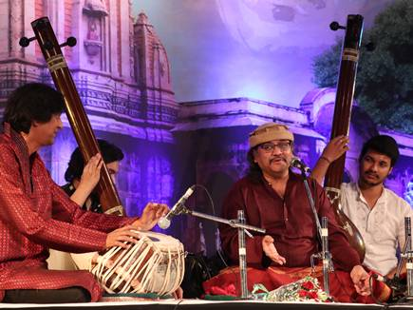

Pandit Raghunandan Panshikar performing at the Amir Khan Festival in 2018

**Music Schools**

1. **Sargam Institute Of Music Arts**

10, Beema Nagar, Gate No.1, Old Palasia, Near Anand Bazar, Palasia Square

Instructor: Varsha Jhalani

Genre: Indian Classical and semi Classical

Facebook: <https://www.facebook.com/sargamtalentshow/>

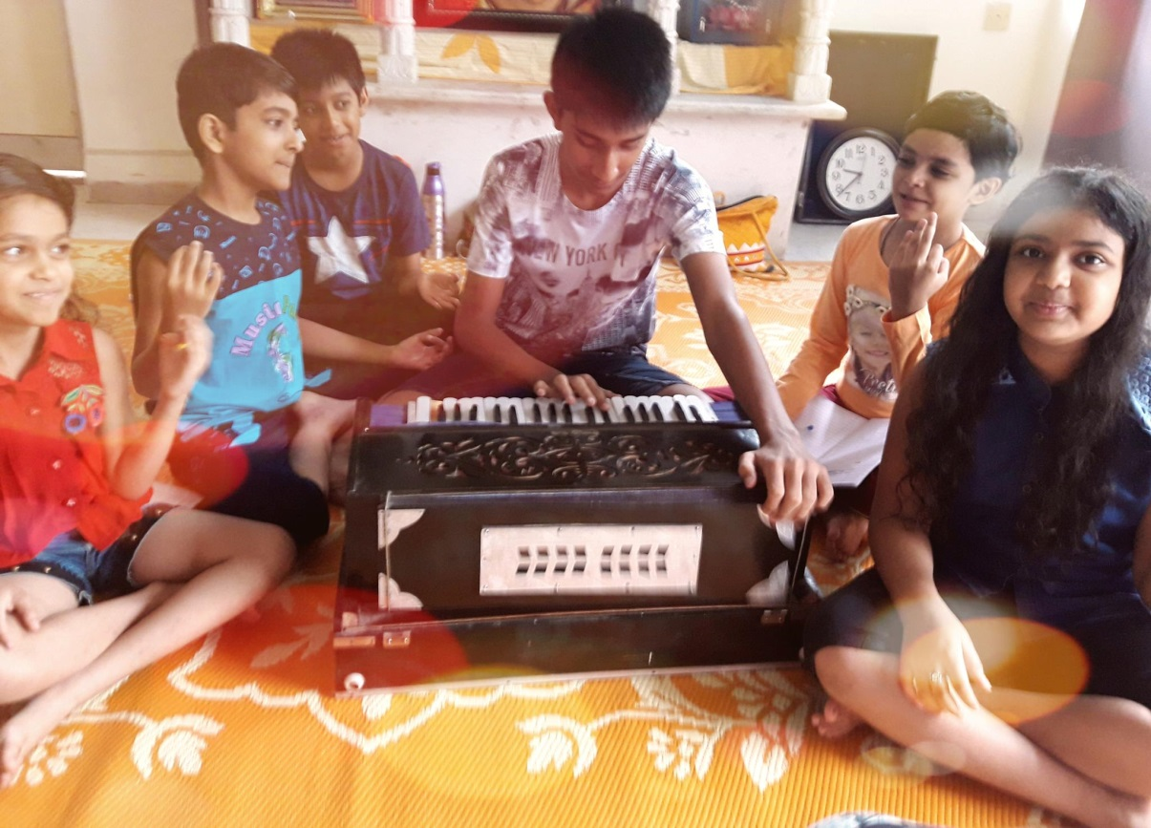

1. **Gautam Kale’s Sangeet Gurukul**

106, Indraprasth Tower, 6 M.G. Road

Instructor: Shri Gautam Kale

Genre: Hindustani Classical

The school runs regular workshops and festivals. Students are selected as per their performance in auditions. Contrary to popular belief, most students are very young and keen to learn and appreciate the Classical style (often considered archaic). Sangeet Gurukul is the best known music school in Indore.

Facebook: <https://www.facebook.com/sangeetgurukulofficial/>

You Tube: <https://www.youtube.com/channel/UC1YEd2BMfxhnA57GEhUFeEw>

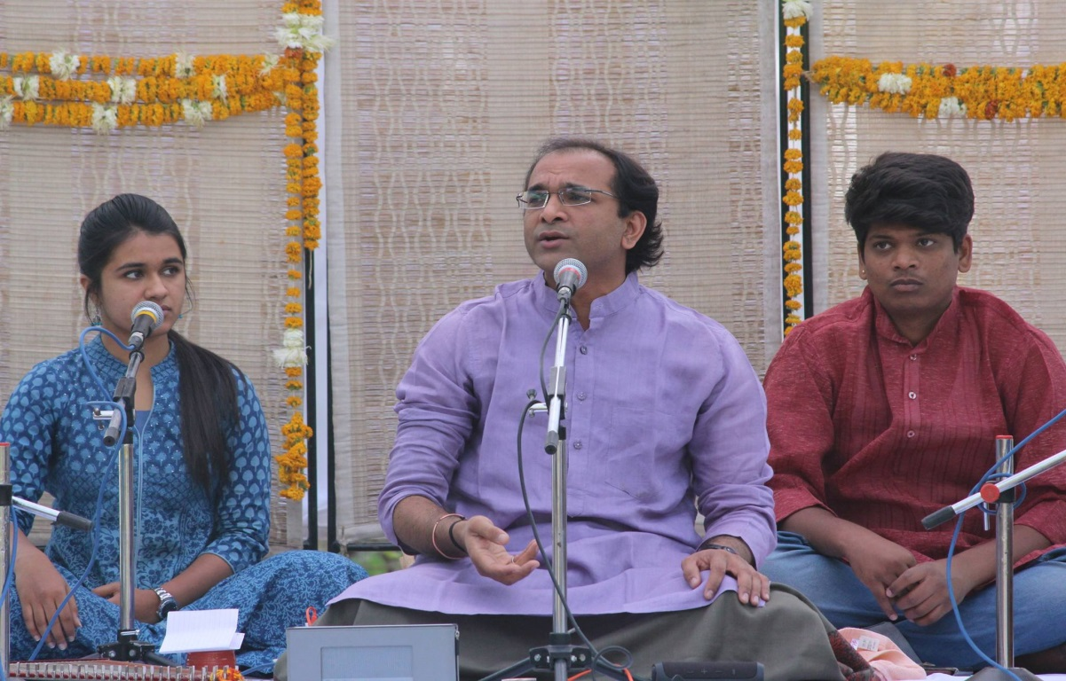

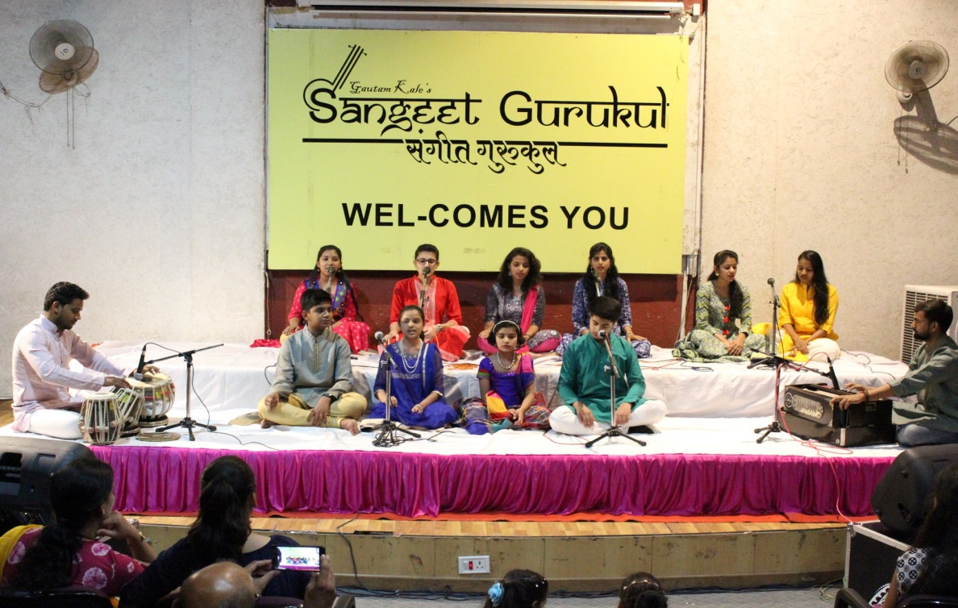

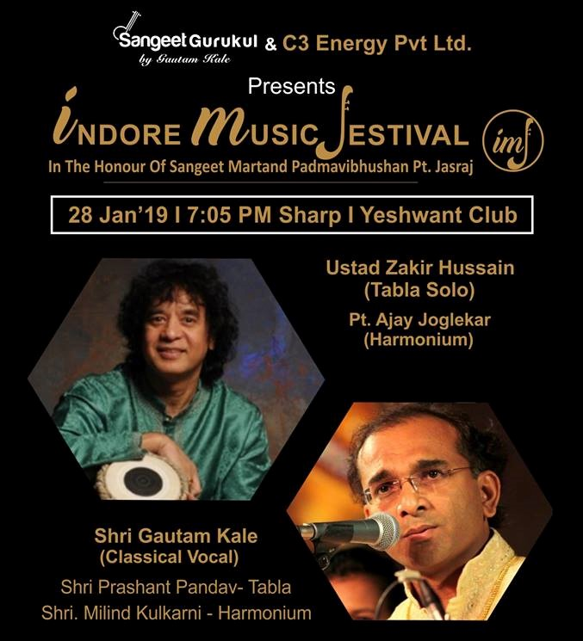

The most recent festival organized by the Gurukul (graced by the presence of Ustad Zakir Hussain).

1. **Indian Idol Academy**

A-34, M.I.G. Colony, near L.I.G.Square (Landmark: R J Sweets)

Established in 2015, the Indian Idol Academy is an official training institute associated with the Indian Idol Brand. The institute was established keeping in view the huge talent pool in Indore which does not receive an adequate platform for expression. The students are periodically taught online by the official Indian Idol mentors (Hariharan, Alka Yagnik, Kavita Krishnamurti, Salim Merchant, Anupama Mandloi, Anand Sharma, Satish Datt, Upal Sengupta, Bikram Ghosh and Sourabh J. Sarkar), while the mentors based in Indore conduct regular classes (classes are held every alternate day for each batch and offer rigorous training).The academy believes in preparing the students for both industries as well as the public spheres and looks at popular music as a ‘performing art’ in the true sense of the term.

Director: Anshul Chhajed

Genre: Popular, Bollywood

Facebook : <https://www.facebook.com/Indianidolacademyindore/>

Instagram: <https://www.instagram.com/explore/locations/1608401536066289/indian-idol-academy-indore/>

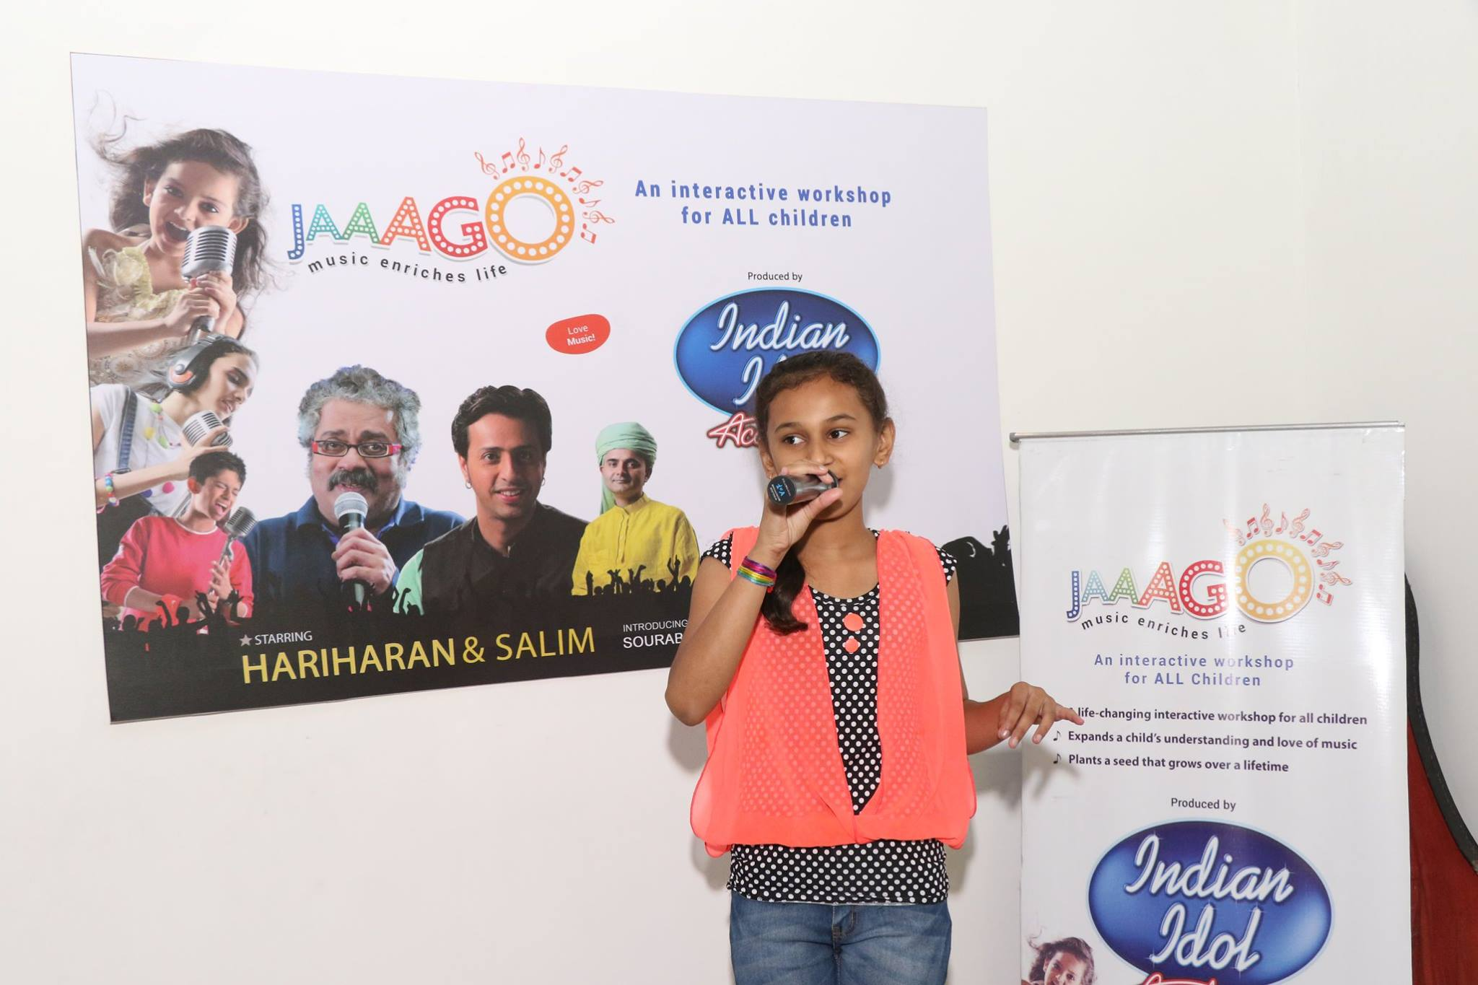

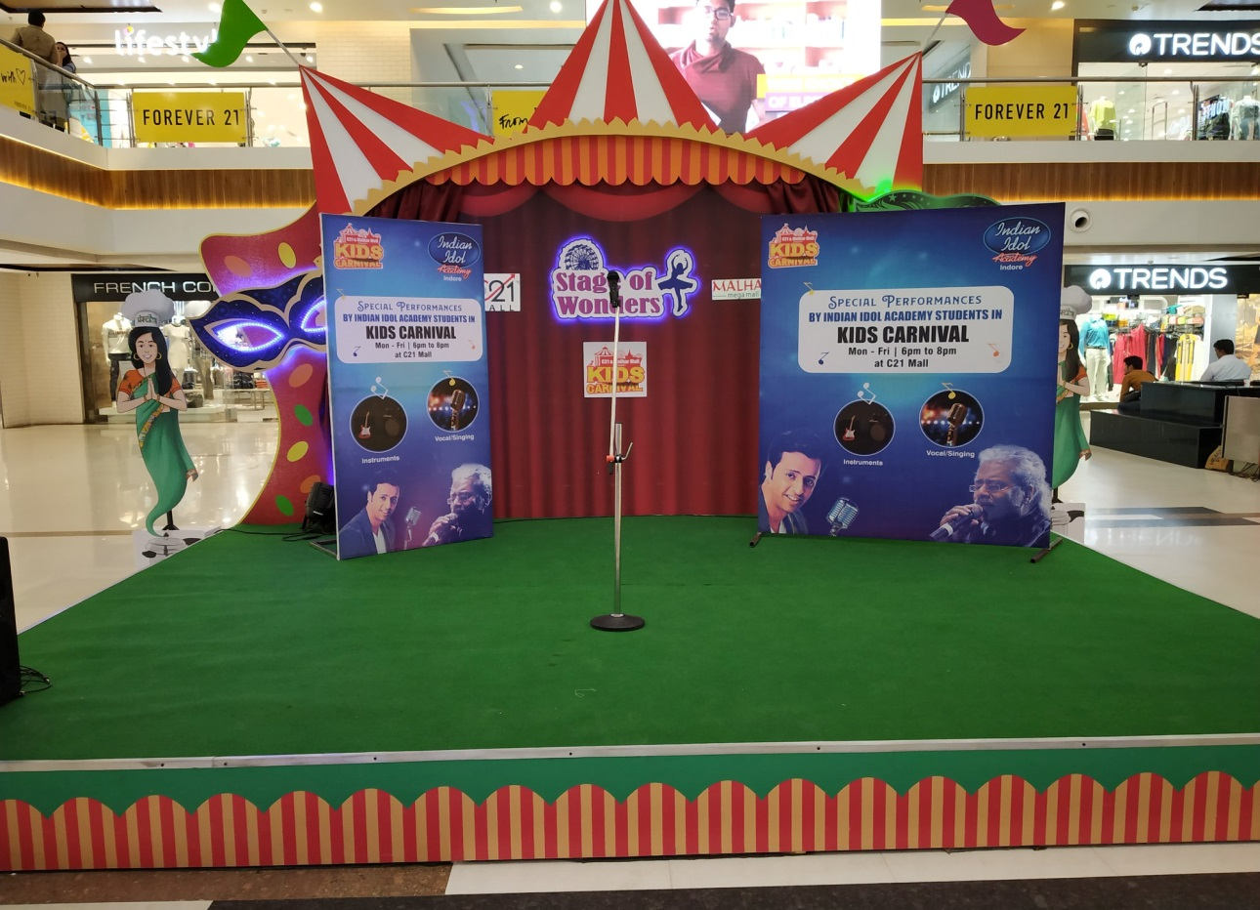

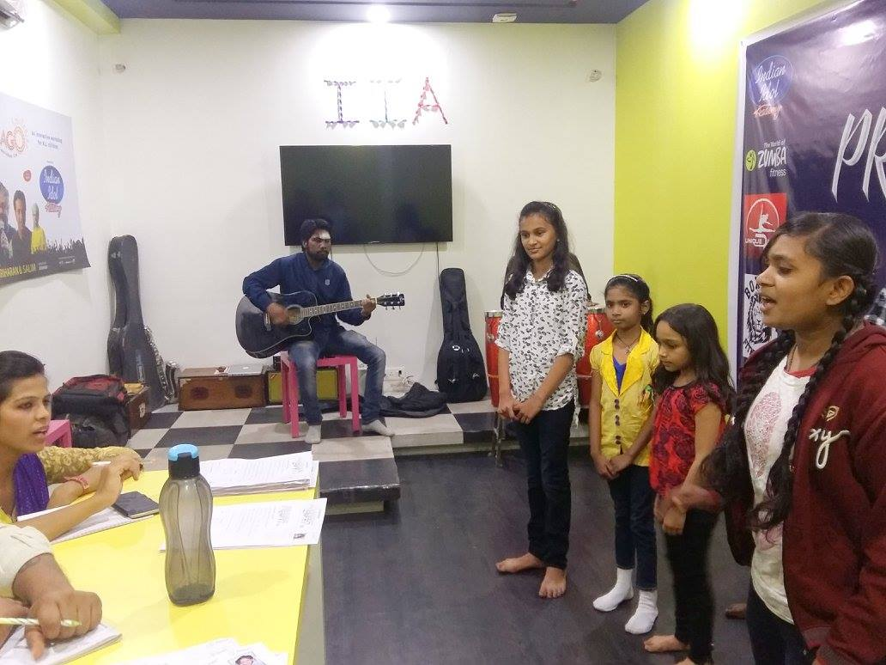

4. **Nadgunjan music class**

EK 322, Scheme No 54, Vijay Nagar, Behind Nissan Showroom

Genre: Indian and Western instrumental

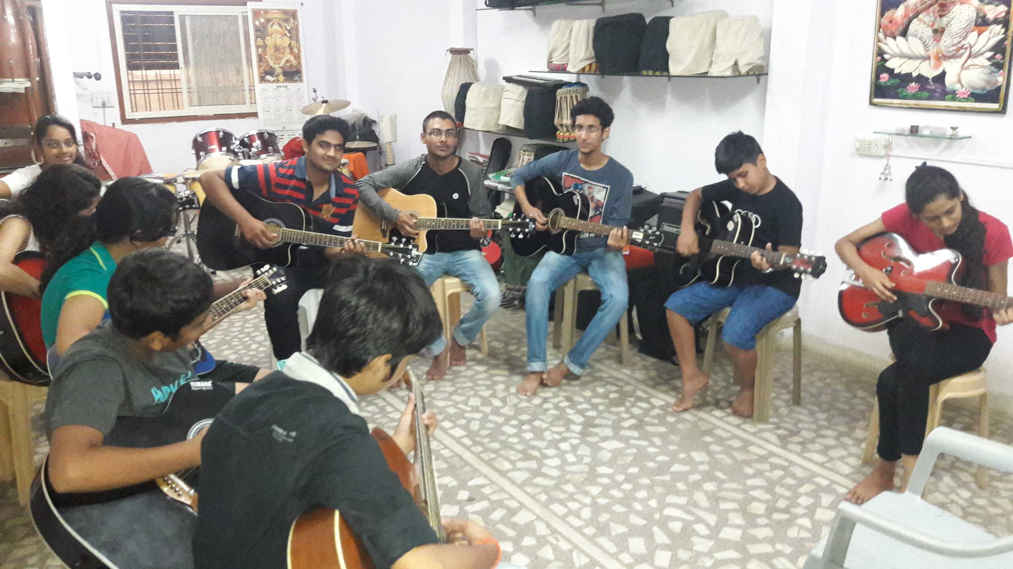

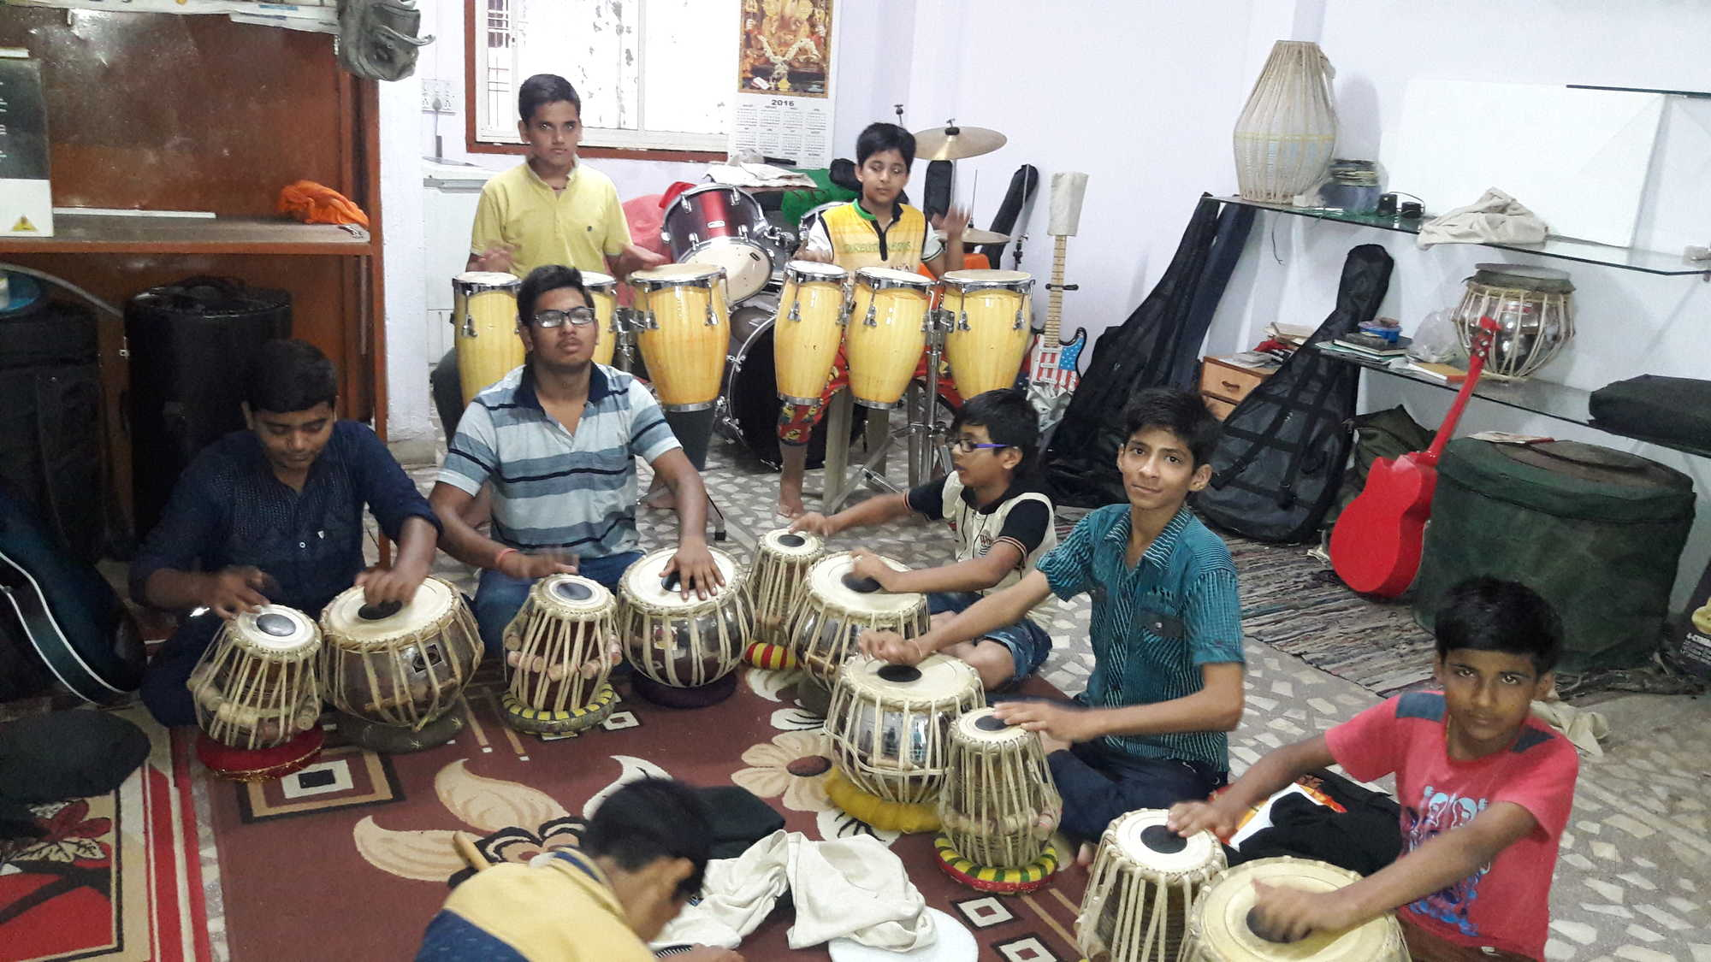

1. **Pancham Nishad Sangeet Sansthan**

73/A, Bhawanipur Colony, HDFC Lane, Annapurna Road

Genre: Hindustani Classical

Established in 1996 by renowned singer Devaki Pandit, Pancham-Nishad is dedicated to preserving and promoting Hindustani (North Indian) Classical musical traditions. The institute is known for arranging concerts ( more than 20 concerts arranged till now) by leading maestros as well as emerging artists. Pancham Nishad is run mostly by volunteers and functions like a non-profit organization. It aims to bridge the gap between the modern academic institutional setting and the traditional Guru-Shishya paramparaa. The school offers training sessions and is open for music enthusiasts (across all ages) in vocal and instrumental Indian Music (Sitar, Tabla, Harmonium, Keyboard). To facilitate the teaching and demonstration of the traditional arts regular lectures, seminars and workshop by leading exponents are held.

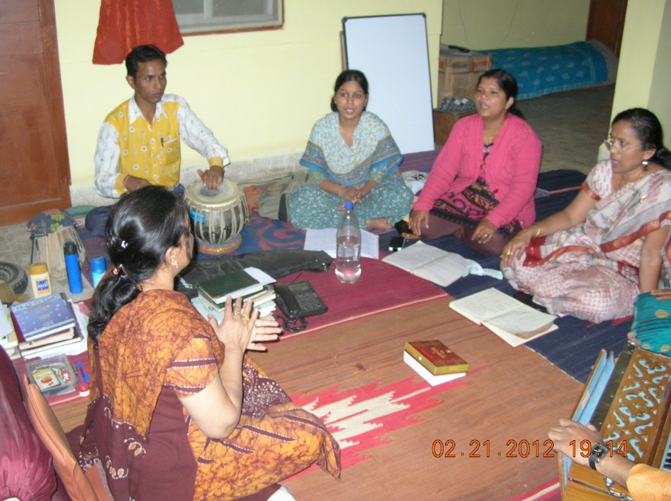

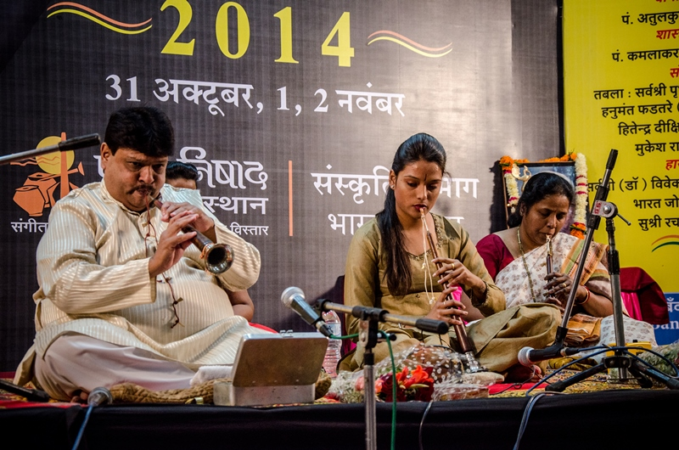

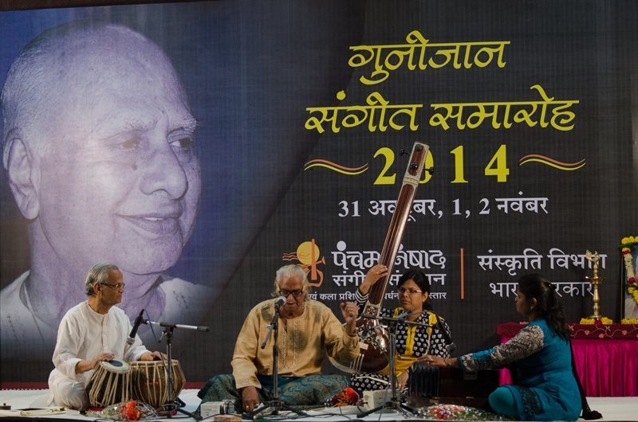

5. **Essence Music Academy**

1123, Sector-C, Near Marthoma School, Nyay Nagar, Sukhlia

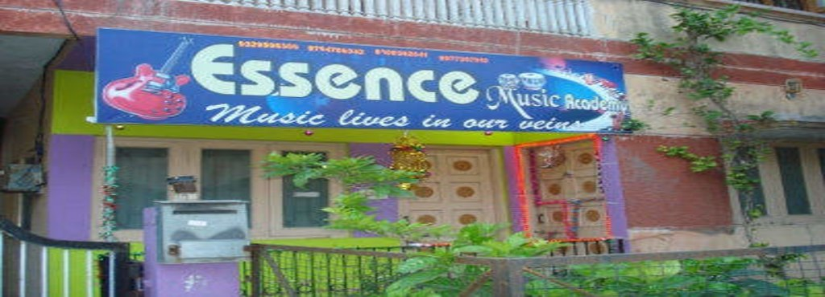

Genre: Indian Classical and Semi Classical (vocal and instrumental), Folk, Music Theory, Western instrumental

6. **JR School of Music & Studio Works**

292, Indrapuri, Near Hello Point

Nominated for All India Education Excellence Award 2013, JR School of Music & Studio Works provides training in both Indian and western music.

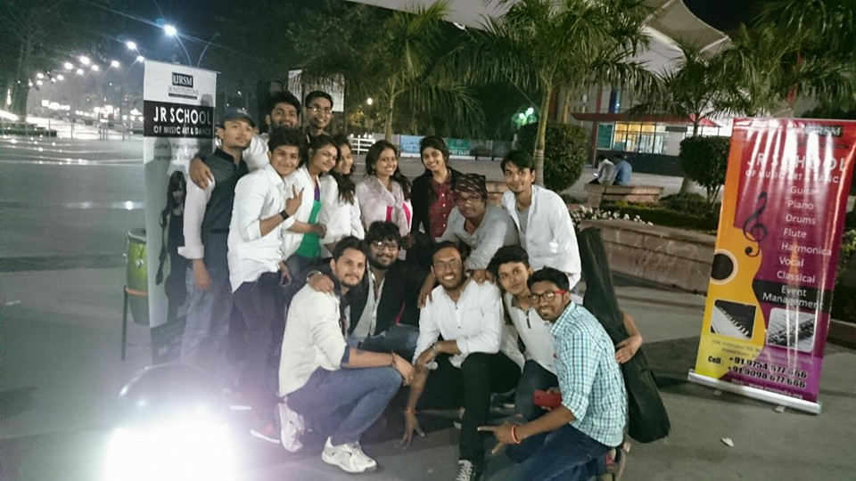

7.**Chatterjee Music & Dance Academy**

Vikram Tower, 547 Fourth Floor, Sapna Sangeeta Road

Genre: Indian and Western instrumental music

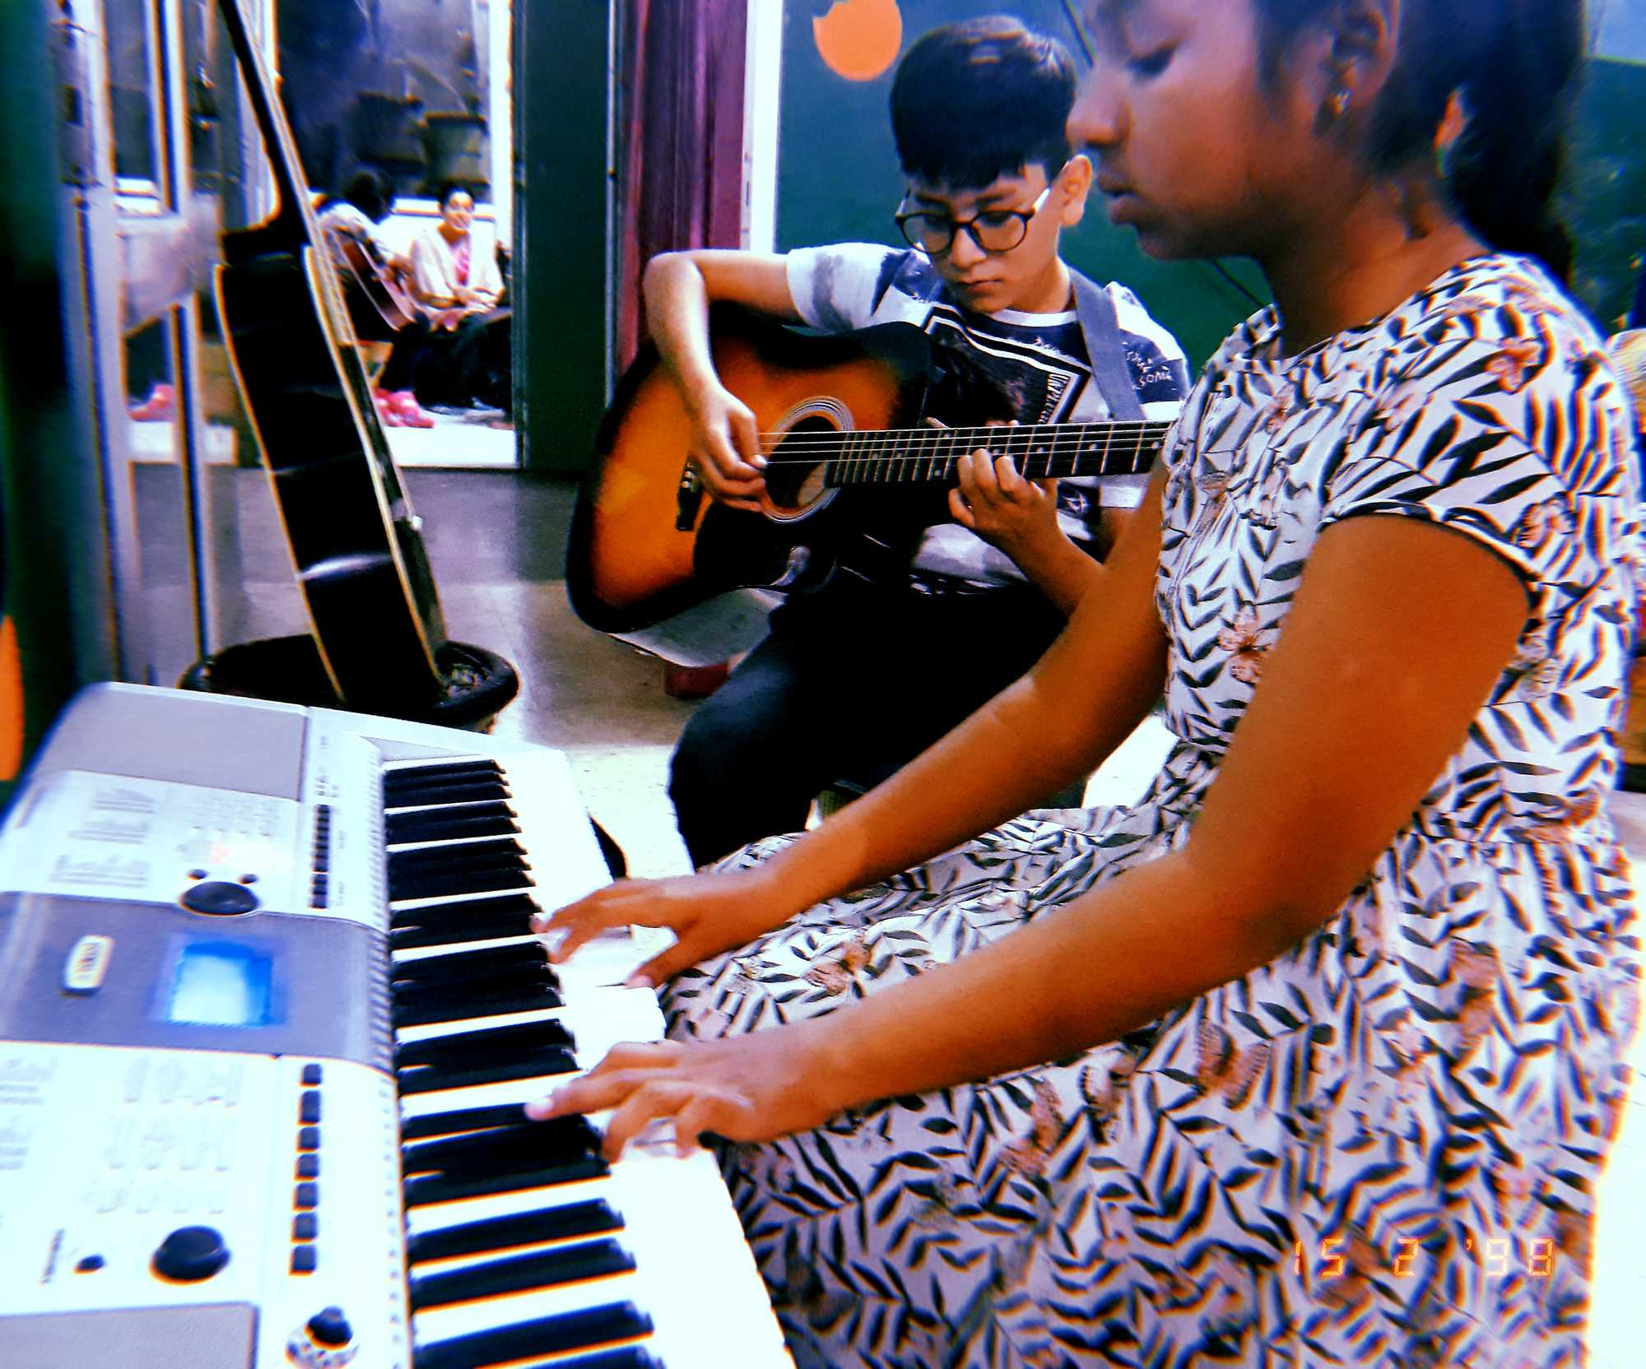

8. **Shree Ram Music Academy**

472/1 Sarwhara Nagar, Nanda Nagar Main Road

Genre: Indian Vocal and instrumental, Western instrumental

9. **Bhartiya Academy Shrikrishna Sangeet Mahavidhyalaya**

G-79, Sector G, LIG Colony

Genre: Indian Instrumental and Folk

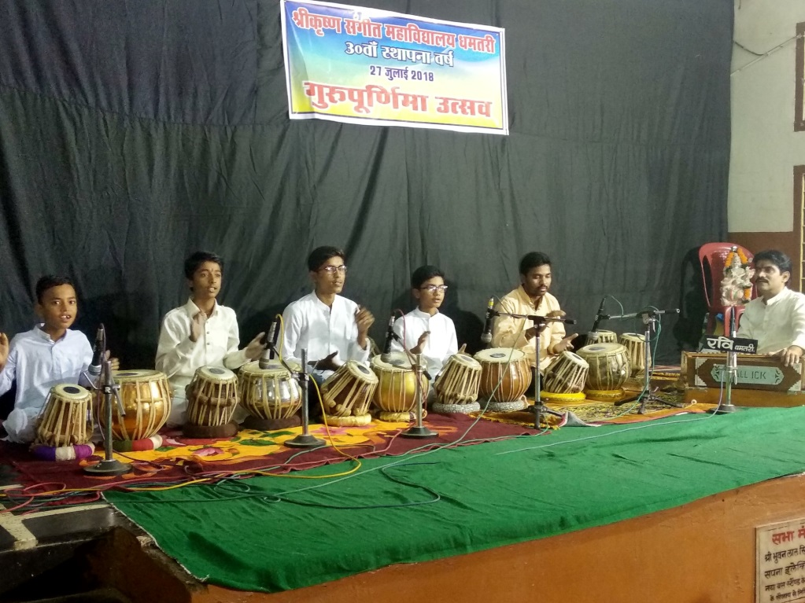

10. **GMC-Government Music College Indore**

Raja Mansingh Tomar Music and Arts University

Subhash Marg, Chiman Bag

Diploma and post graduate degrees in several specializations of music and dance are offered.

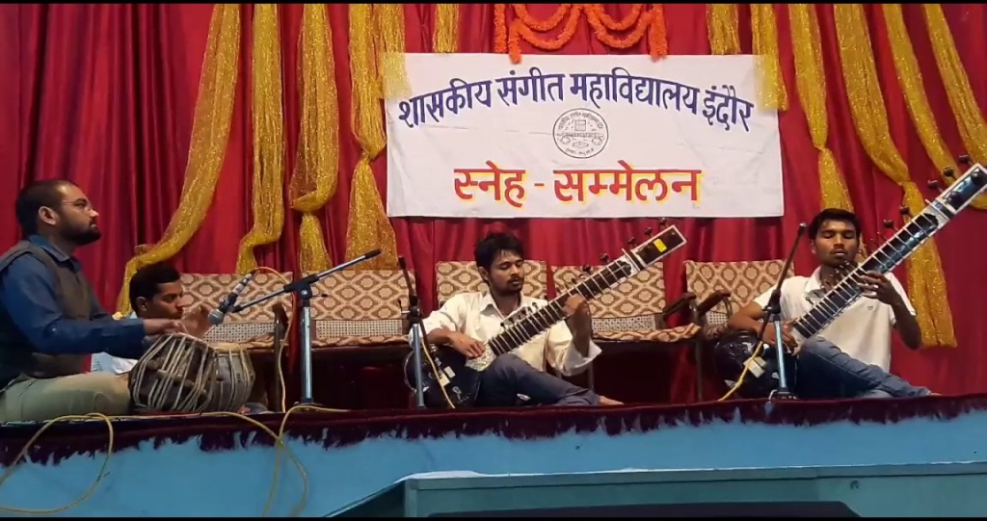

11.**Rhythm Soul Institute of Music & Fine Arts**

310, 3rd Floor, Akashdeep Complex, Opposite Tanishque Jewellers, Sapna Sangeeta Road

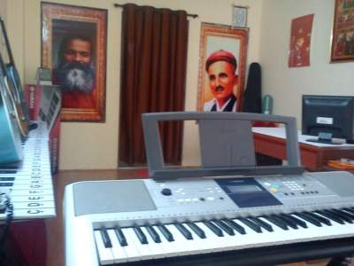

12. **Zen Musical Institute**

F-15, Suparvashnath Apartment, LIG Main Road, LIG Colony

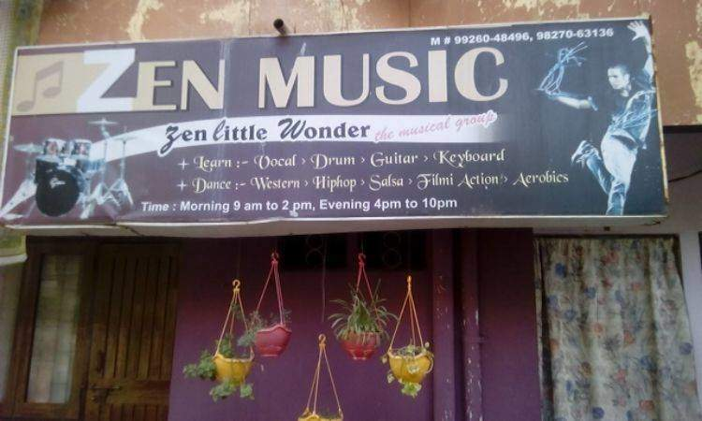

13. **The Phoenix Institute**

61/3, Manorama Ganj, New Palasia, Opposite Royal Heights, Near Mayank Hospital

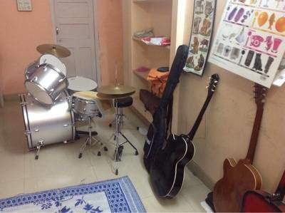

14. **Kala Niketan**

Khandwa Road

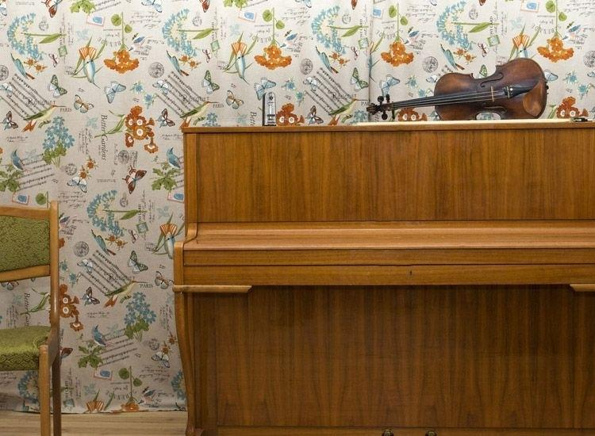

15.**Taal Sangeet Classes**

675-R, Near Pioneer College, Opposite Bombay Hospital, Mahalaxmi Nagar

16.**Euphony Music Academy**

35, Navya Park Building, Lalaram Nagar, Manoramaganj, Near St Paul Institute Of Professional Studies and Gita Bhavan

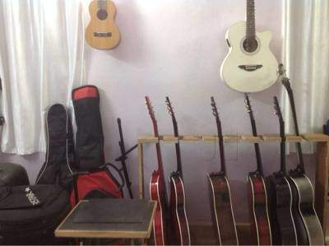

17. **Anakars Music**

92 Brijeshvari N X, Bengali Chowk, Near Kaali Mata Mandir, Near ECS School

18. **S & J Class**

Arpit Apartment, 34, Saket Nagar

(Detailed descriptions of all these music schools along with images will be later added)

**Live Music Venues**

***Concert Halls***

1. **Abhay Prashal Auditorium**

10/1, abhay prashal, Race Course Road

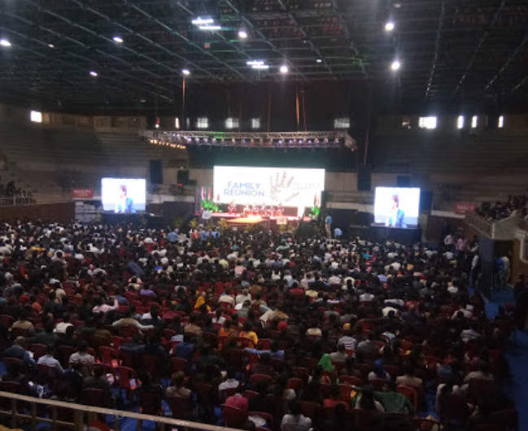

2. **Ravindra Natyagrah**

Plot No 1, RNT Road

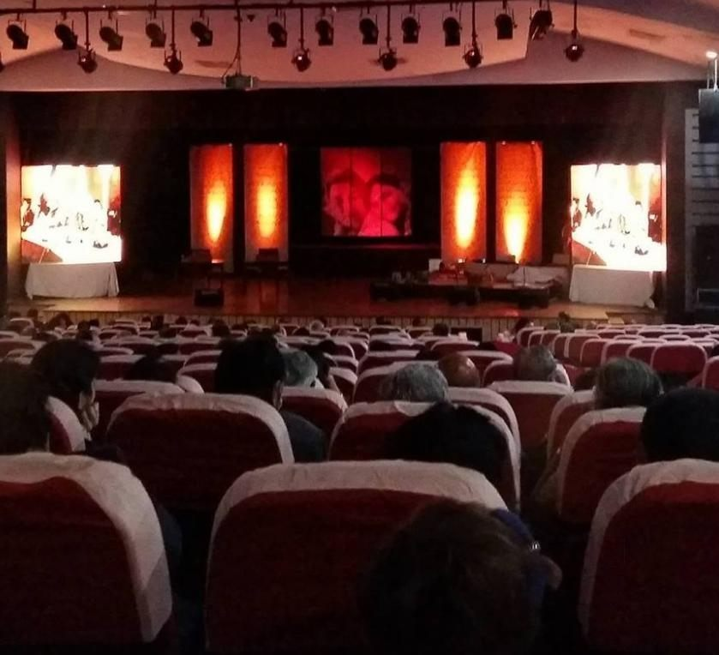

3. **Anand Mohan Mathur Auditorium**

Sheetal Nagar, Kushabhau Thakre Marg

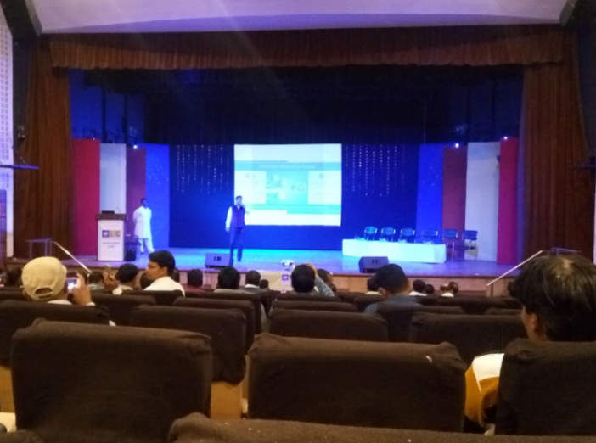

1. **Pritamlal Dua Auditorium**

Mahavir Empire, No G10, Regal Chouraha, Rnt Marg, South Tukoganj

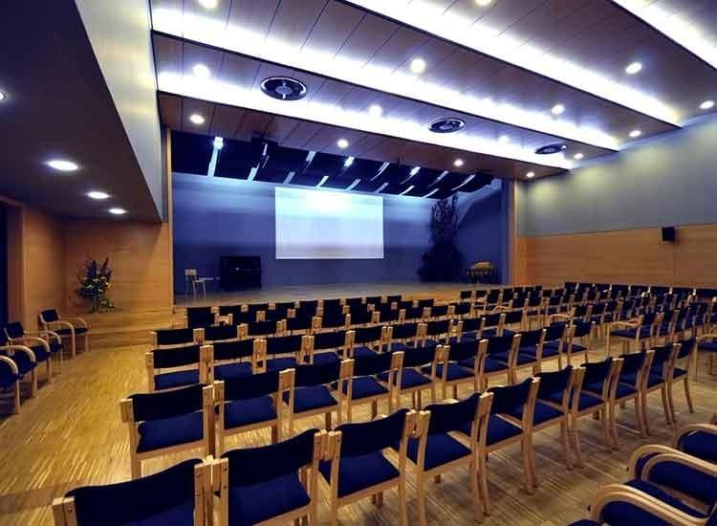

1. **Mai Mangeshkar Auditorium**

Near Snehnagar, Panchsil Nagar, near Lohamnadi Iowa School, in front of Sapna Sangeeta Road

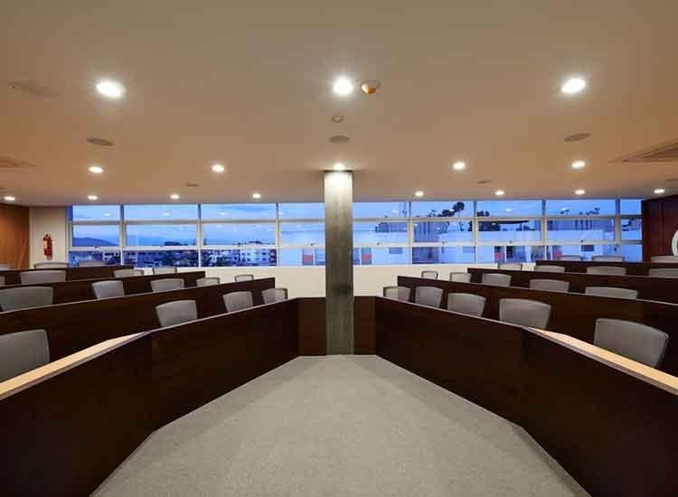

1. **Anand Mohan Mathur Auditorium**

Scheme No 54, Vijay Nagar

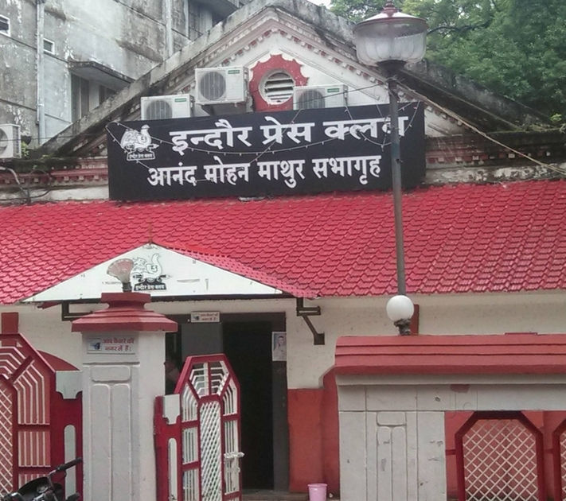

1. **Shree Jal Auditorium**

South Tukoganj, Opposite Noble Hospital

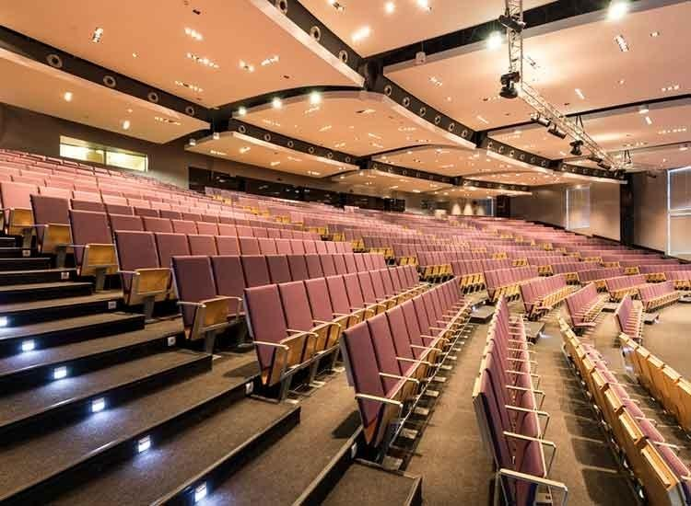

1. **Navrang Singh Saini Auditorium**

35, Navrang Plaza, Navlakha, Sapna Sangeeta Road

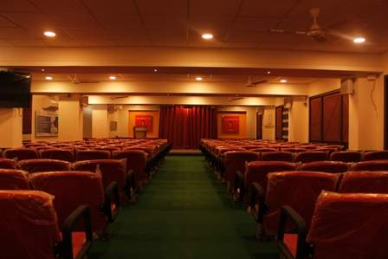

1. **Shri Aditya Vikram Birla Auditorium**

Musakhedi, Opposite SBI

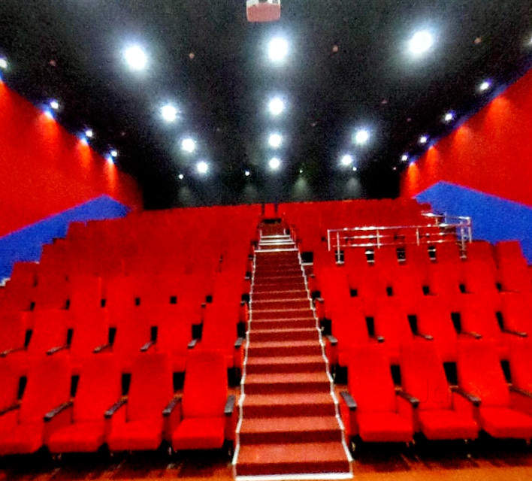

**Cafes/Restaurants**

1. **Masala Medley Cafe**

Golden Tower, Basement 94, Sapna Sangita Sneash Nagar Main Road, Patel Nagar

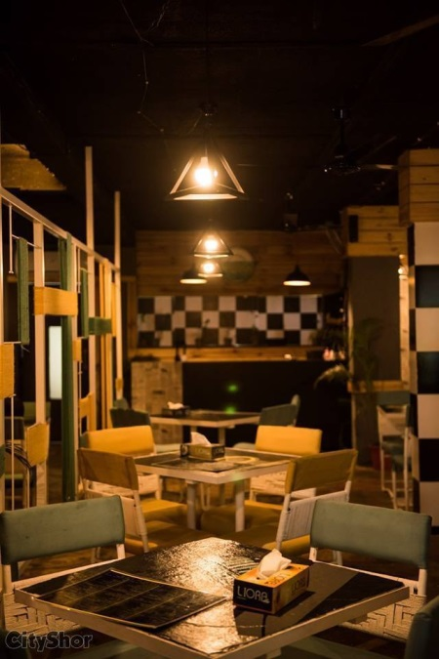 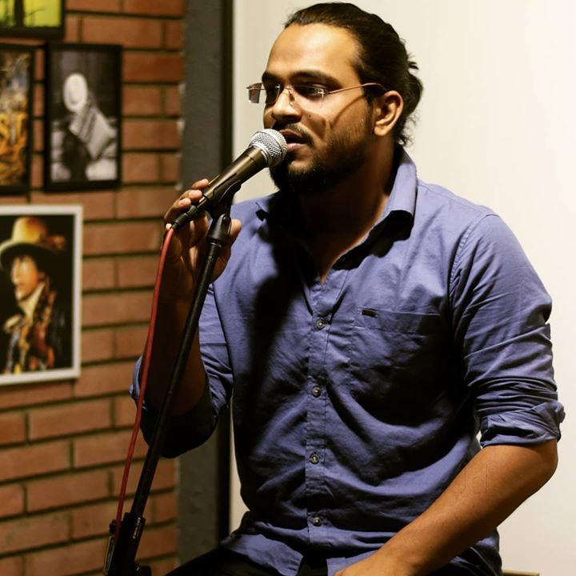

1. **The Eyry**

GF, Narayan Kothi, 18 R S Bhandari Marg, Zanzeerwala Square

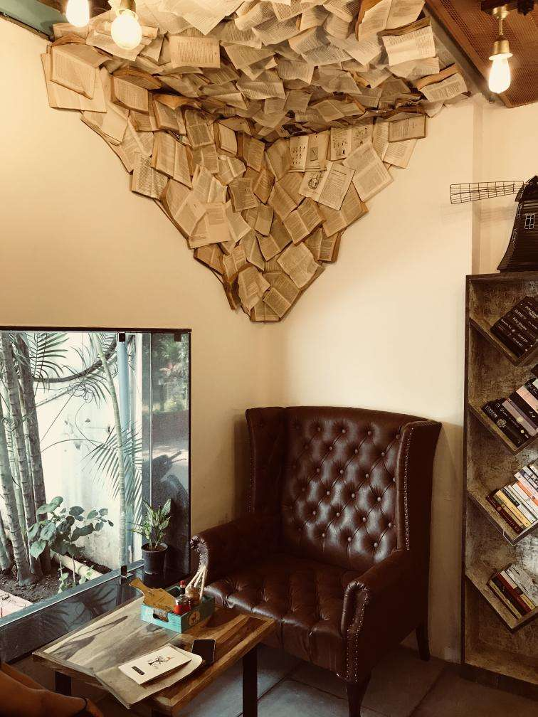

1. **Taberna The Cafe Bar**

Scheme 94 C, Velocity Multiplex Ring Road

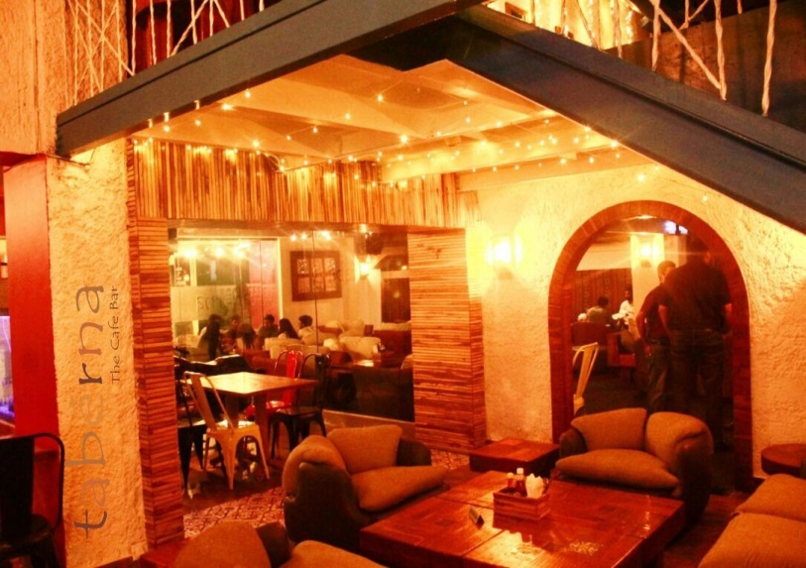 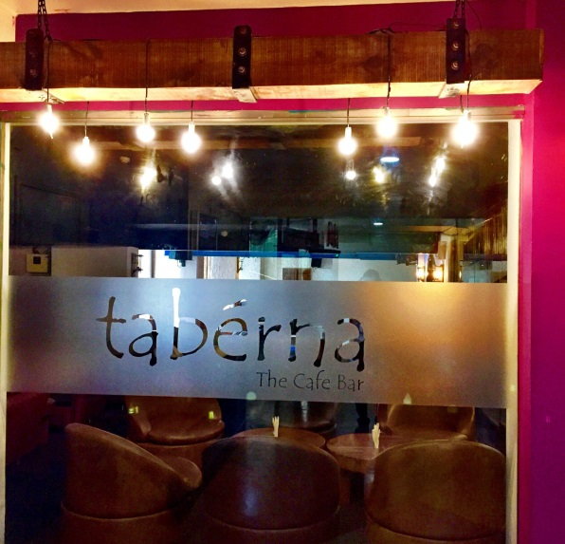

1. **Shosha Cafebar**

Vijay Nagar, Near Hotel Wow

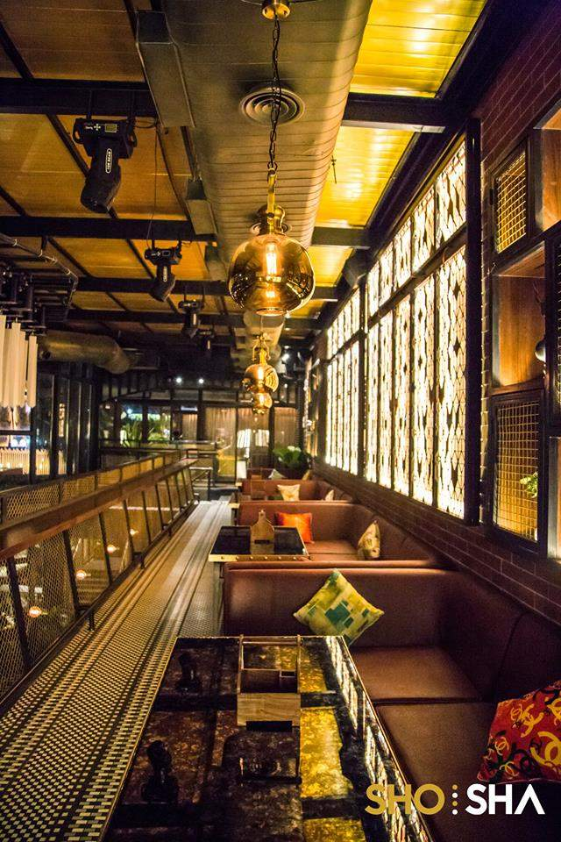

1. **The Piano Project**

11th Floor, Apollo Premier, Plot 1, Scheme 54, Pu4, Vijay Nagar

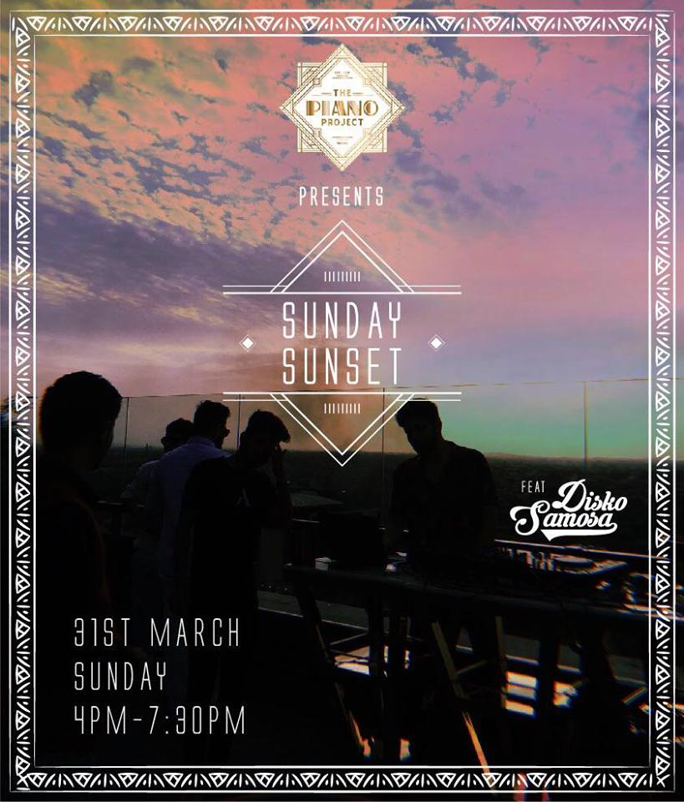

1. **Freito**

Pu4, Ab Road, Vijay Nagar, Country Inn

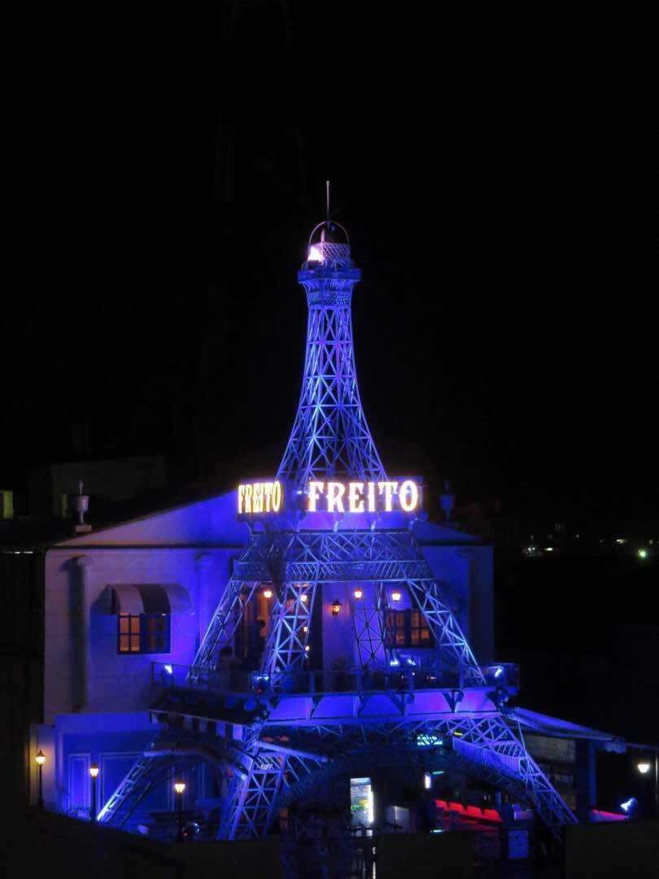

1. **Kyro**

6 Floor, Roof Top, Fortune Aura, Bhawar Kuan Road, Bhawar Kuan



1. **Indiya Oye (radisson Blu Hotel)**

C/O Radisson Blu Hotel, 12, Ring Road, Vijay Nagar

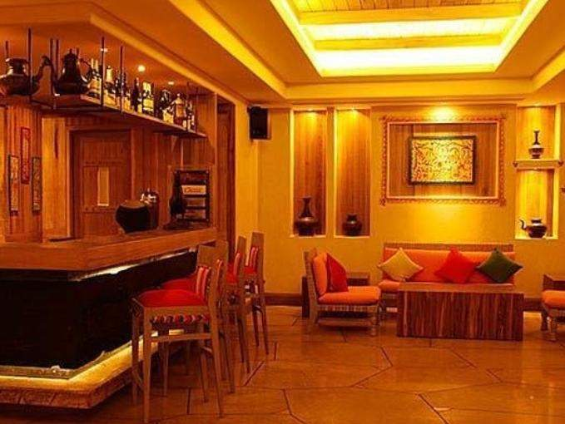

1. **Calypso Club N Lounge**

4th Floor, C 21 Mall, A B Road, Vijay Nagar

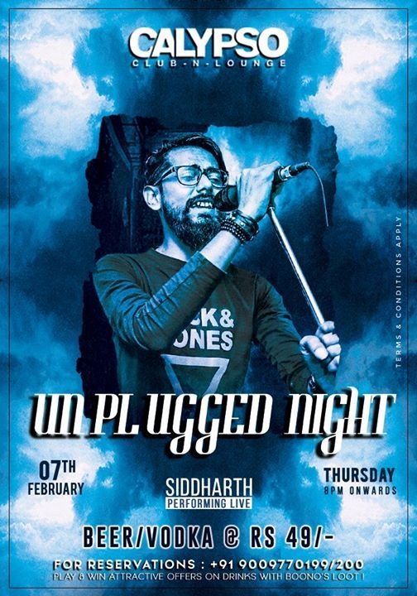

1. **Pitchers Cafebar**

4-5, Scheme No.140, Satguru Parinay, Vijay Nagar

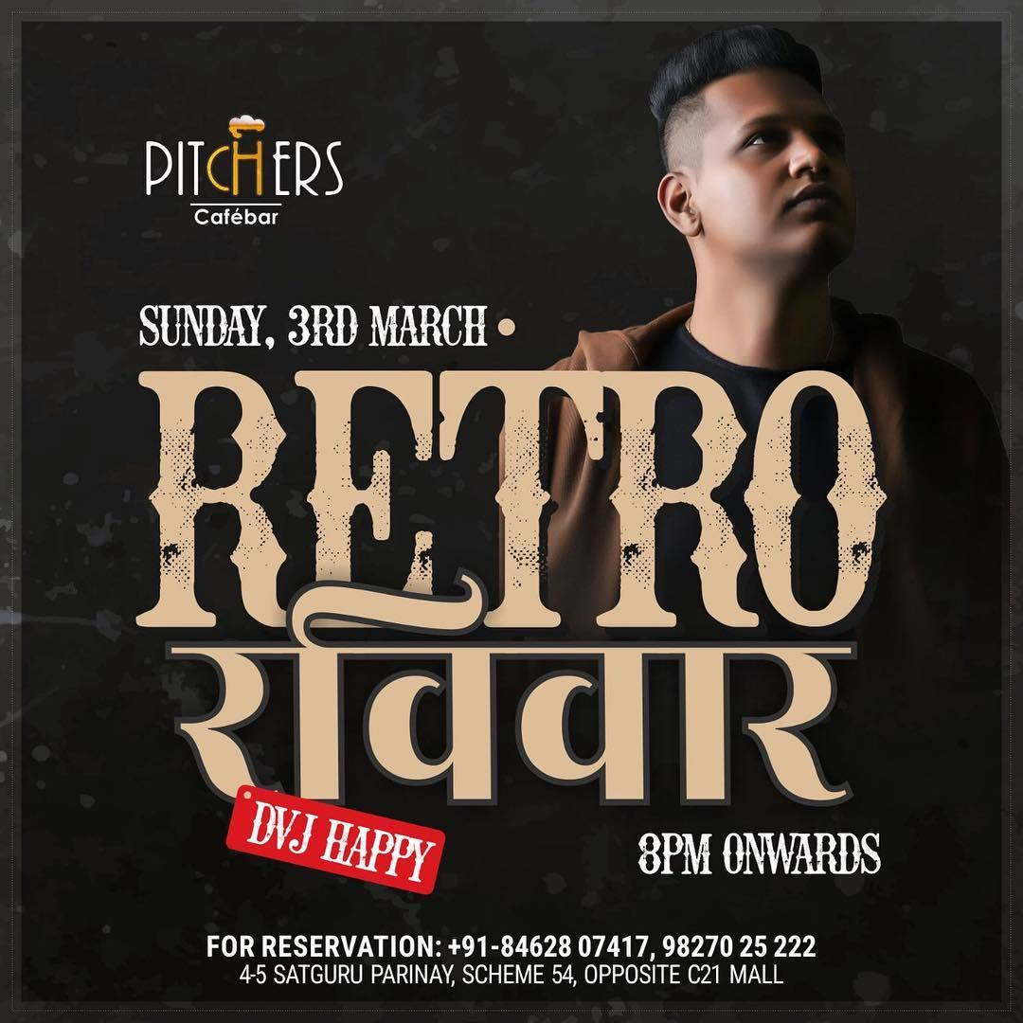

Heritage Sites and Musical Landmarks (associated with music – are yet to be covered)

Interviews with artists performing in the places mentioned above (and a few other prominent ones) will be covered during April mid-last (fieldwork due, I will find some time after end term). Also, more detailed write up on each venue will follow. I will wrap up significant details April end.

**Music Stores**

1.**Jingle Bells**

Apollo Tower, 170-171, 2, Mahatma Gandhi Rd, New Palasia

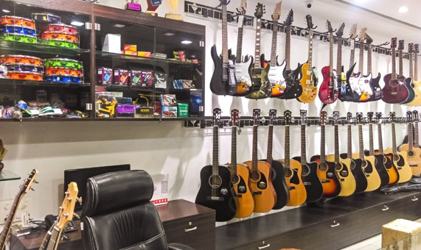

2.**Kilbil Creations**

88, Tilak Path, Ram Bagh

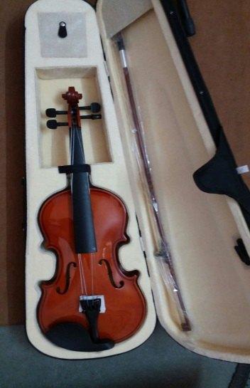

3.**Mech Music (Modern Educational cultural heritage of music)**

1st floor, Ganapati building, 19/2 , Y.N Road, Above Milan TVS Service Centre

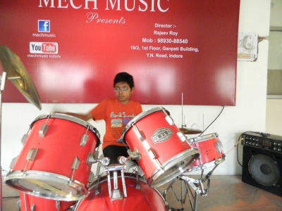

4.**bavander.com**

Lakshya Square, Rani Bag Main, Khandwa Road

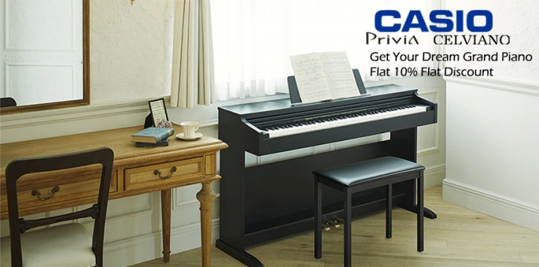

5.**RK Musicals**

Between Mashjid and Jain temple, 135, Kanadia main Rd, Sanvid Nagar, near Patrakar Colony

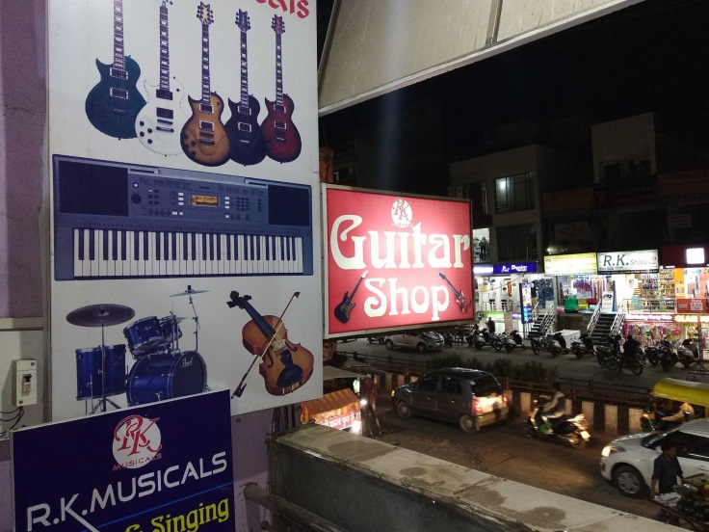

6.**Total Music**

Hotel Crown Palace Rorad, M 5 & 6 Trade Center, 18 South Tukogunj

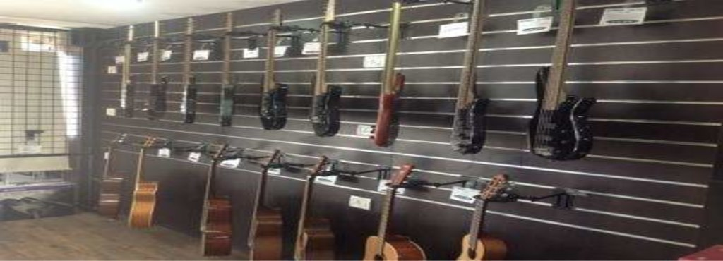

7.**Narayani Music Shop**

Meghdoot Plaza Building, Scheme No.54, Vijay Nagar

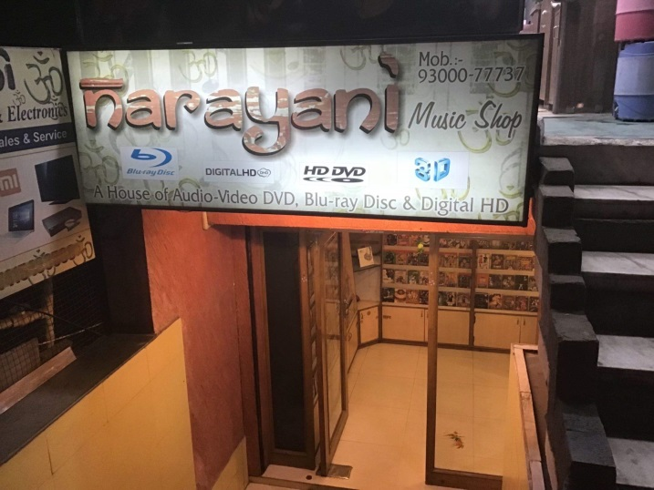

8.**Keys & Chords**

182 Near BJP Office, Ushaganj, Jaora Compound

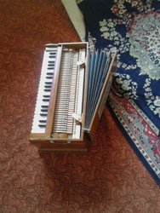

9.**Swar Sangit**

70,Malganj Square

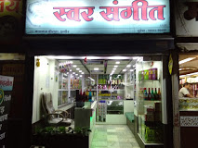

10.**RDX Music Store**

Yeshwant Plaza, 105 Second Floor, Near Railway Station

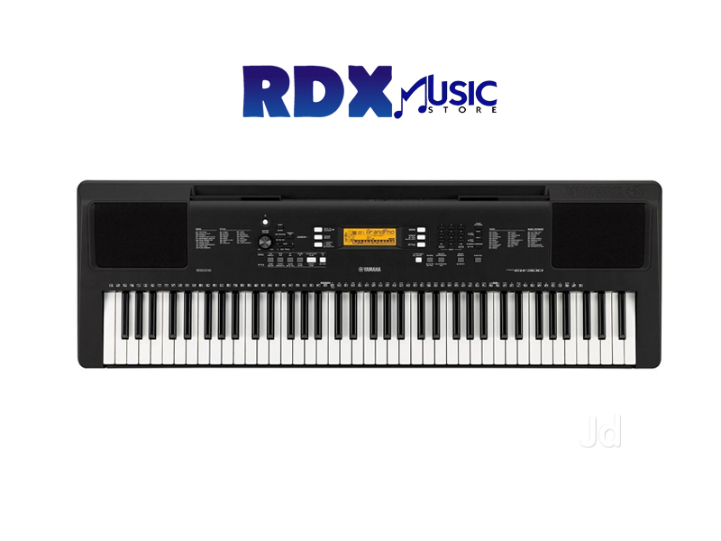

**Recording Studios**

1. **Aalaap Studio**

27/2 Leela Building, New Palasia

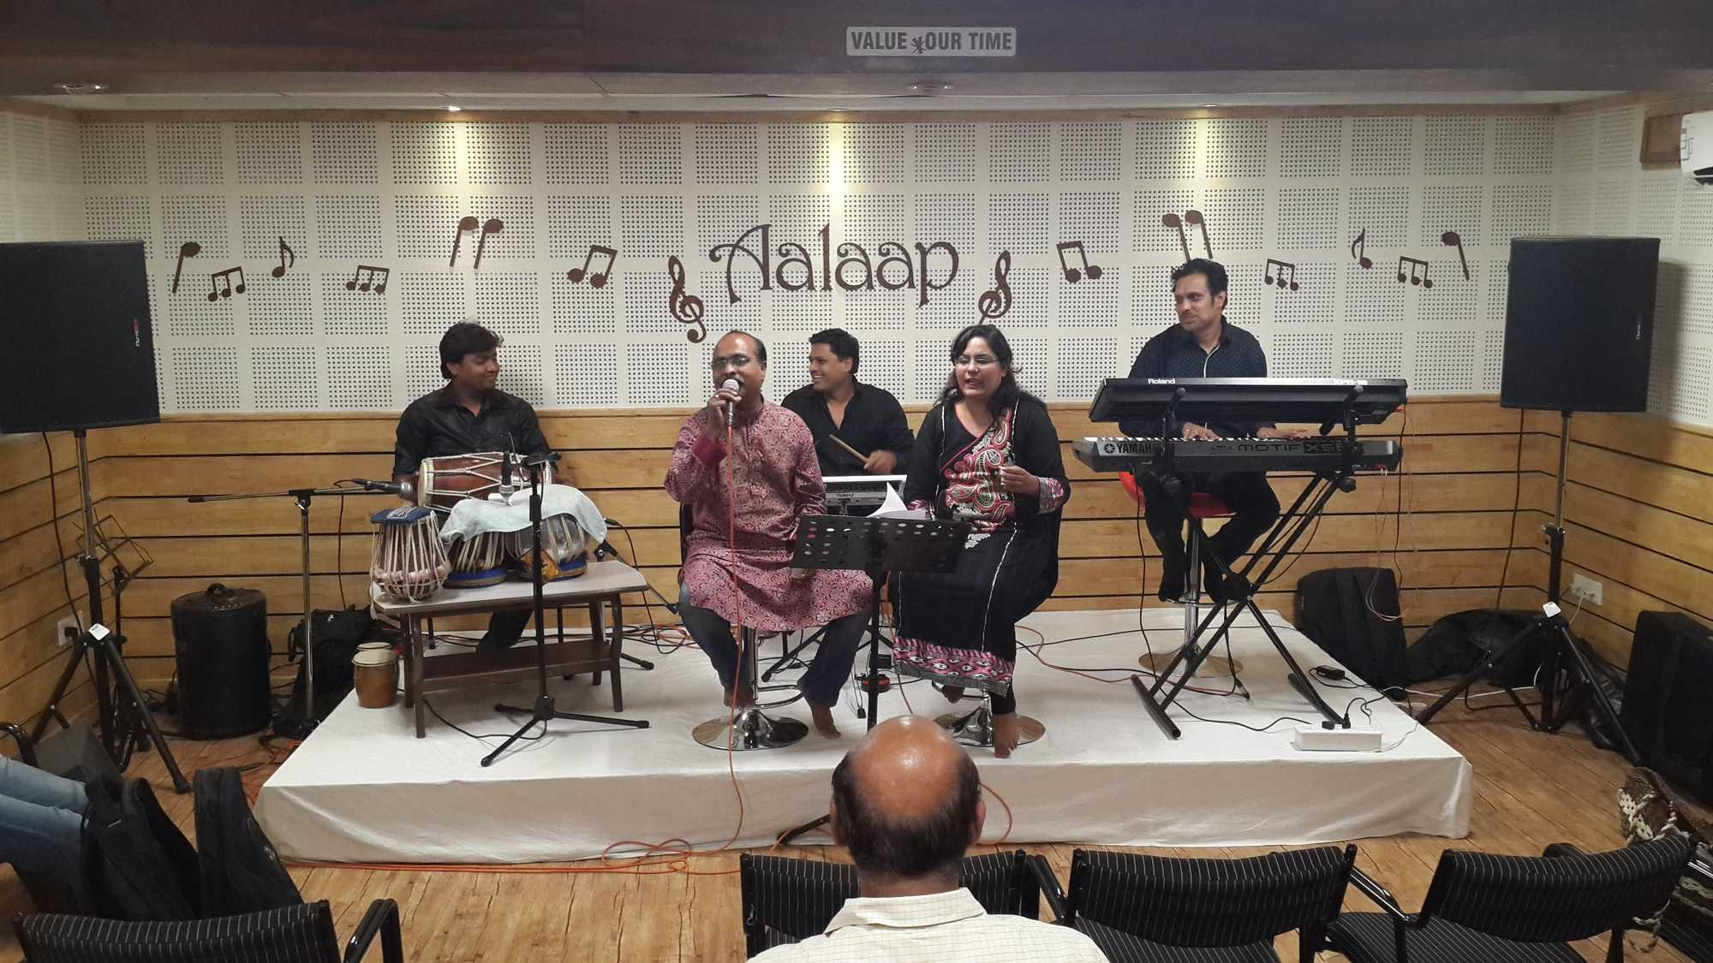

1. **Spectral Audio**

97, Scheme No 113, Vijay Nagar, Near Brilliant Convention Center

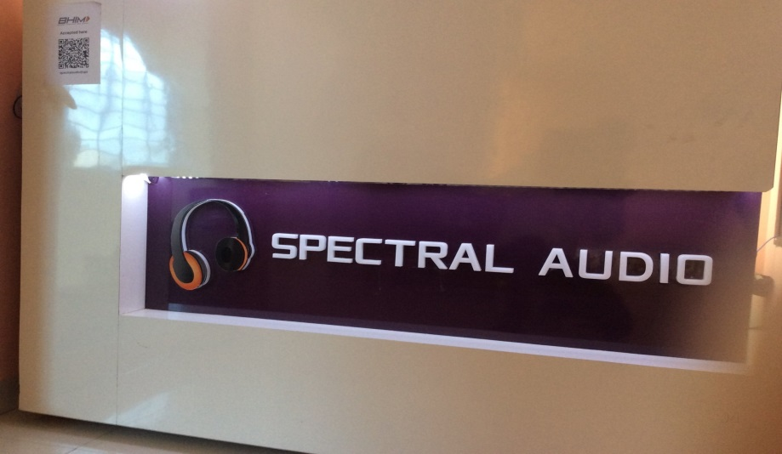

**3. Renovation Music Studio**

49, Greater Tirupati Colony, Geeta Nagar, Lalaram Nagar, New Palasia

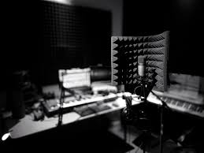

**4. Dot WAV Studios - Audio & Video Production**

111 Trade Center, South Tukoganj, Opposite Jain Mandir

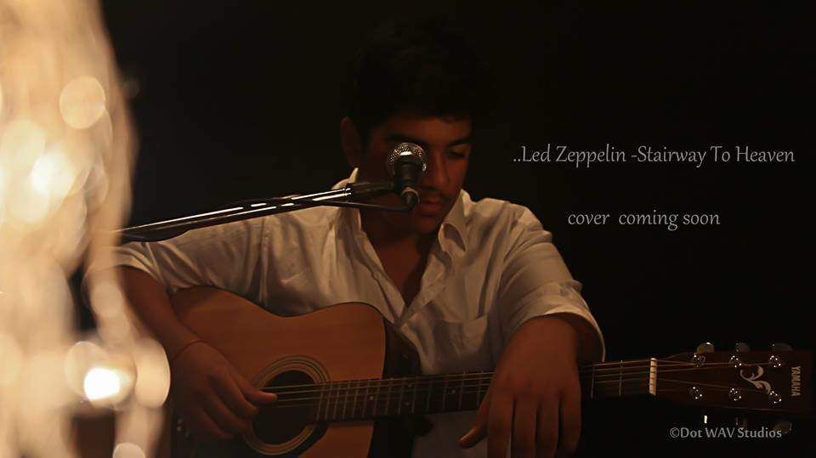

**5. DMS studio**

202 Lemon Tower, Sutar Gali, Jail Road

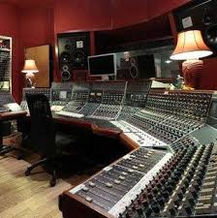

**6. DSP Digital Recording Studio**

315, Muley Tower, MG Road

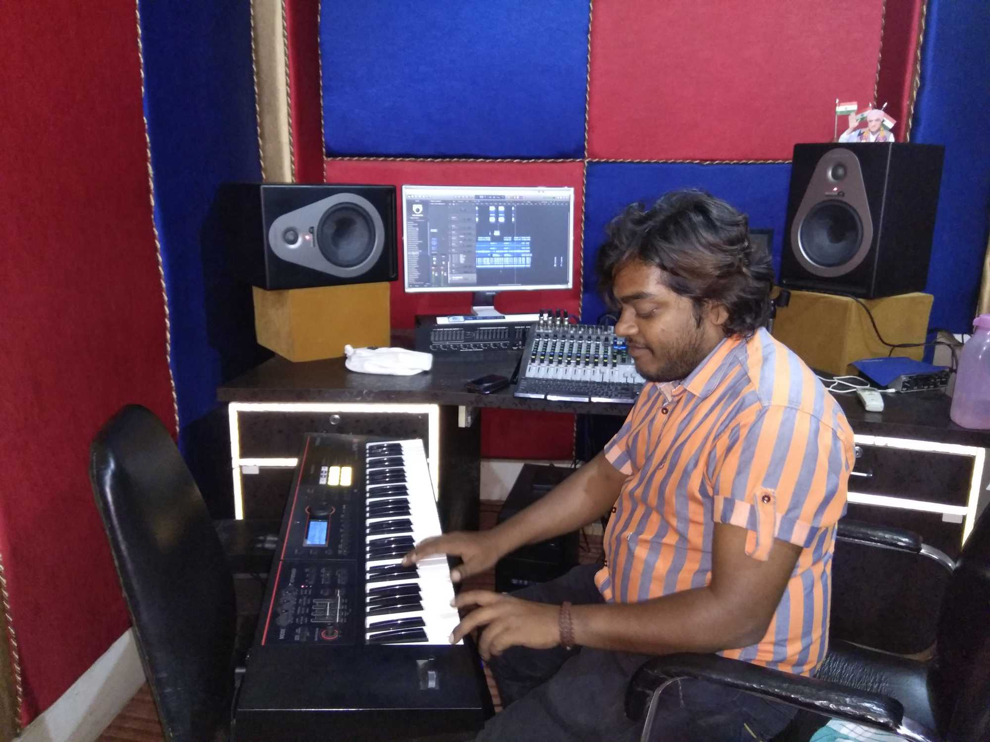

**7. Soundcafe**

303, Utkarsh Plaza, 8 Chandralok Colony



**8. Rad Recordzz Studio**

Flat No 301, Aniket Apartment, Rajendra Nagar

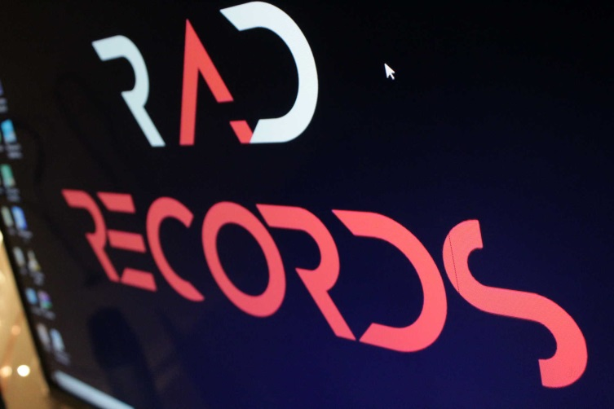

**9. Illuminati Music Academy**

53 Building, Main Road, Sangam Nagar, Near Police Chawki

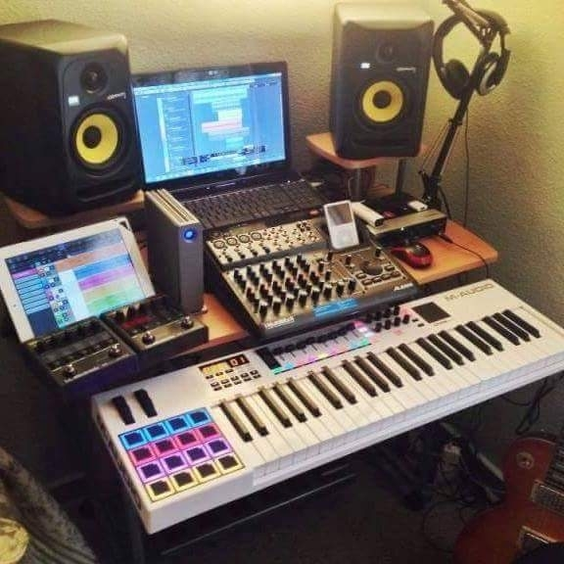

**10. Swarankan Digital Recording Studio**

Jaora Compound, 182, St, Ushaganj, Murai Mohalla

